AUSTROADS TEST METHOD ATM 058
Aggregate Shape by the Ratio of Greatest
to Least Dimension

Commentary
Contents

1. References…………… 2

2. Equipment……….…….. 2

3. Procedure…………….. 2

4. Calculation…………… 2

5. Reporting……………… 3

Amendment Record…….. 4

Scope
This method sets out the procedure for assessing aggregate shape as a ratio of Average Greatest Dimension (AGD) to Average Least Dimension (ALD).
Further Development
None proposed.

References
The following documents are referred to in this method:
Australian Standard
AS 1141.20.1 | Methods for sampling and testing aggregates, Method 20.1: Average least dimension – Direct measurement (nominal size 10 mm and greater)
AS 1141.20.2 | Methods for sampling and testing aggregates Method 20.2: Average least dimension – Direct measurement (nominal sizes 5 mm and 7 mm)

Equipment
- AGD measuring trough graduated in divisions of 1mm (see Figure 2.1)
Figure 2.1: AGD measuring trough
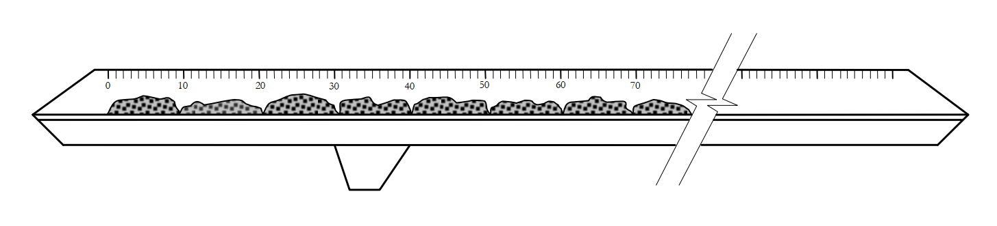

Procedure
- Carry out the procedure for determining ALD as described in AS 1141.20.1 and AS 1141.20.2.
- On completion of the measurement of the least dimension and sorting of all the particles in the test sample into groups of nominal least dimension, place the aggregate particles of each group in a line, just touching, with their greatest dimension along the trough described Figure 2.1.
- ‘Nominal Least Dimension’ means the mid point between the upper and lower limits of each size range used to sort the particles into groups in the ALD test.
- ‘Touching’ means no visible gap when viewed from vertically above but also no overlap. Physical contact between particles is not a requirement.
- Record the total length of each line of particles to the nearest millimetre.

Calculation
- Divide the total length of each line by the number of aggregate particles in the line to determine the AGD of each group.
- Divide the sum of the lengths of each line by the sum of the numbers of aggregate particles in each line to determine the AGD of the sample.
- Divide the AGD of each group by the nominal least dimension of each group to determine aggregate shape of each group.
Note that this ratio is recorded as indicative of the shape for each group but is not reliable where the number of aggregate particles in the group is less than 15% of the total number used to determine the ALD (i.e. minimum 100).
- Divide the AGD of the sample by the ALD of the sample to determine the aggregate shape of the sample.

Reporting
The following shall be reported:
- The ratio of AGD to Nominal Least Dimension of each group to the nearest 0.01.
- The ratio of AGD to ALD of the sample to the nearest 0.01.

Amendment Record
Amendment no. | Clauses amended | Action | Date
- | New Test Method |  | November 2023

Key
Format | Change in format
Substitution | Old clause removed and replaced with new clause
New | Insertion of new clause
Removed | Old clauses removed

Acknowledgement
This Austroads Test Method is based on New Zealand Test Method TNZ T/5 Method of determining size, shape and grading of Grades 1-4 sealing chips and Transport for New South Wales Test Method T278 Aggregate Shape by the ratio of Greatest to Least Dimension.

